Little SPARK: Simple Play Adaptations to Reference for Kids

Outdoor Gate Alarm
Description: | Image:
1 Gate Alarm and 1 Remote Controller. The magnetic sensor will alarm immediately when the two items are separated more than 0.6 inches. Requires 4 - AAA batteries.  Purchasing Information | 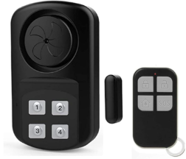

Who Might Benefit?
Those who supervise children who wander, act on impulse and try to open doors or gates, or follow other children who open doors or gates.
Why Use?
Provides an opportunity to act as a safety measure for those who try to leave due to overstimulation, feeling upset or frightened, wandering from supervised areas, or attention seeking.
Instructions for Use: | Adaptation Ideas:
Environmental Considerations  - Be aware noise level may affect certain children.  - Create boundaries such as a taped box in front of the doorway as a “no stand zone”.  - Place the desk or table where the teacher spends the most class time close to the door to allow for quick intervention.  - Place a stop sign on door or outside gate.  Positioning  - Strategically place the child away from an accessible door.  Play/Use with Others  - Create and place a poster about leaving the area to be reviewed daily in morning circle/meeting.  - Combine poster or social stories about leaving designated areas with community signs/traffic lights with concepts of stop, go, and wait/caution.  - Play Red Light Green Light game and discuss instances of when it is important to stop, and OK to go. | Communication Support  Visuals displaying options of things children can say or do when they feel like they need to "get away".  - Create lanyards for all staff with visuals including stop, wait, I need a break.  - Create an individual or class Social Story (e.g. Staying With My Class, Running Away, I Can Choose to Be Safe).  DIY Alternatives  - “Sleigh bells” or other movement triggered noisemaker on doors and gates.  - Stop signs posted on doors and gates.  - If home has a security system, check to see whether a door alarm can be activated when door opens and/or closes.
Words to Encourage Play/Use
Stop  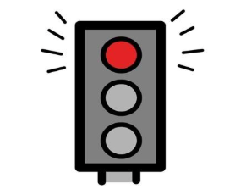 | Go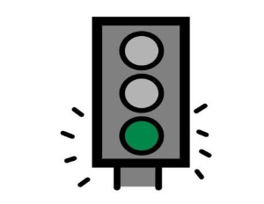 | Wait  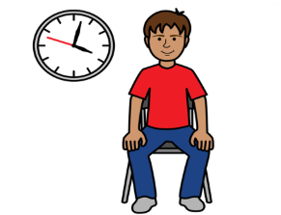
Open 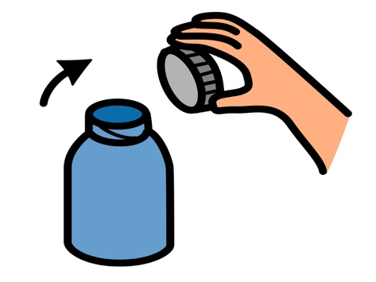 | Close 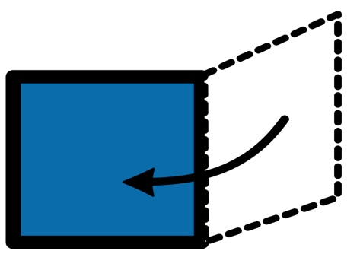 | Help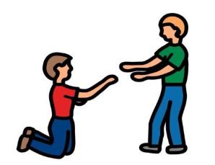
Sad 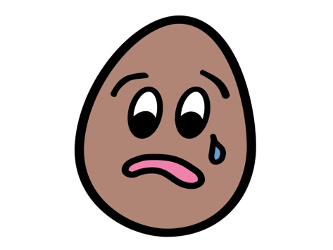 | Mad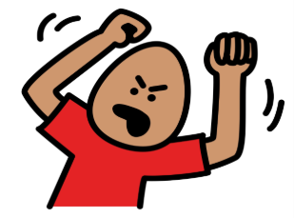 | Scared  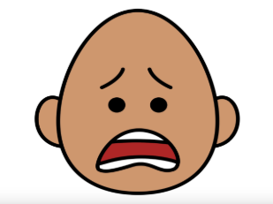
*”Adaptations” adapted from: Haugen’s Modes for Adapting Toys based on materials from the "Let's Play" Project at the University of Buffalo
PCS is a trademark of Tobii Dynavox, LLC. All rights reserved. Used with permission.

